H.T No
Regulations:
A17

Sreenidhi Institute of Science and Technology
(An Autonomous Institution)
Code No: 6W104 Date: 05-Feb-2020 (FN)

M.Tech I-Year I-Semester External Examination, Jan/Feb-2020 (Supplementary)
ADVANCED MECHANICS OF SOLIDS (CAD/CAM)

Time: 3 Hours Max.Marks:75

Note: a) No additional answer sheets will be provided.
b) All sub-parts of a question must be answered at one place only, otherwise it will not be valued.
c) Missing data can be assumed suitably.

Part - A Max.Marks:25

Answer all QUESTIONS.

1. | Define Principle of super position with an example. | [3M]
2. | What is meant by shear centre? | [3M]
3. | Explain the term Geometry of the contact surface | [3M]
4. | Elaborate Saint Venant’s Principle. | [3M]
5. | Explain Yield and Failure criteria. | [3M]
6. | Sketch the stress distribution ahead of the crank-tip in a machine element under fracture loading conditions. | [2M]
7. | What is Work Hardening of a material? | [2M]
8. | Mention any three assumption from a general Torsional Problem. | [2M]
9. | Enlist theory of failures and explain any two. | [2M]
10. | What is the significance of Green’s theorem in Fracture Mechanics. | [2M]
Part – B Max.Marks:50
ANSWER ANY FIVE QUESTIONS. EACH QUESTION CARRIES 10 MARKS.

11. | a) | State and prove Castiglianos’s first theorem. | [5M]
 | b) | A beam AB of span 3m is fixed at both ends and carries a point load of 9KN at a distance of 1m from support A. The moment of inertias are shown in fig.1. Using Castigliano’s theorem, calculate the reactions and moments.  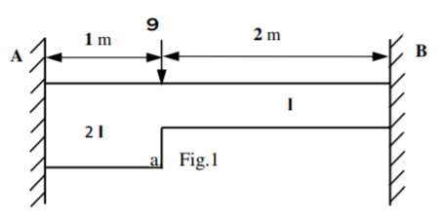 | [5M]
12. | a) | Derive equations of equilibrium for an axi-symmetric problem. | [5M]
 | b) | Determine the shear centre of the section shown in fig.2. The thickness of the section is 10mm throughout the cross-section. All dimensions are in mm  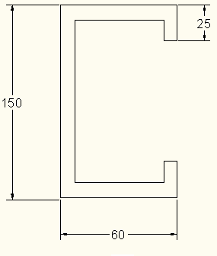  Fig.2 | [5M]
13. | a) | State the assumptions and limitations in Winkler Bach theory for curved beams. | [5M]
 | b) | Determine the radius of curvature of the centroidal axis and the radius of curvature of the neutral axis of a curved beam whose cross-section is a trapezoid as shown in the figure below.  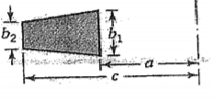  Fig:3 | [5M]
14. | a) | Explain the application of membrane analogy in solving torsion problem of prismatic bar of any cross-section for finding twisting moment and shear stress acting on the cross-section. | [5M]
 | b) | Derive an equation of angle of twist per unit length for a thin wall subjected to a torque T. | [5M]
15. | a) | Derive an expression for buckling load of a clamped column. | [5M]
 | b) | Explain how the Raleigh-Ritz method is used in the design of columns? | [5M]
16. | a) | Differentiate between LEFM and EPFM. | [5M]
 | b) | Design the considerations: K as a failure criterion and J-integral as a fracture criterion. | [5M]
17. | a) | How the shear center is determined in an unsymmetrical I-section and T-section. | [4M]
 | b) | Explain the method of computing contact stresses. | [3M]
 | c) | Write short notes on Griffith energy balance. | [3M]

-- 00 -- 00 –

